FTMK SMART TIMETABLE ARRANGEMENT SYSTEM FOR STUDENTS

FAZRINA BINTI MAJHARDEEN

UNIVERSITI TEKNIKAL MALAYSIA MELAKA

BORANG PENGESAHAN STATUS LAPORAN

JUDUL: FTMK SMART TIMETABLE ARRANGEMENT SYSTEM FOR STUDENTS

SESI PENGAJIAN: 2025 / 2026

Saya: ____FAZRINA BINTI MAJHARDEEN___________________

mengaku membenarkan tesis Projek Sarjana Muda ini disimpan di Perpustakaan Universiti Teknikal Malaysia Melaka dengan syarat-syarat kegunaan seperti berikut:

- Tesis dan projek adalah hakmilik Universiti Teknikal Malaysia Melaka.
- Perpustakaan Fakulti Teknologi Maklumat dan Komunikasi dibenarkan membuat salinan unituk tujuan pengajian sahaja.
- Perpustakaan Fakulti Teknologi Maklumat dan Komunikasi dibenarkan membuat salinan tesis ini sebagai bahan pertukaran antara institusi pengajian tinggi.
- * Sila tandakan ()

__________ | SULIT | (Mengandungi maklumat yang berdarjah keselamatan atau kepentingan Malaysia seperti yang termaktub di dalam AKTA RAHSIA RASMI 1972)
__________ | TERHAD | (Mengandungi maklumat TERHAD yang telah ditentukan oleh organisasi / badan di mana penyelidikan dijalankan)
__________ | TIDAK TERHAD

(TANDATANGAN PELAJAR) |  | (TANDATANGAN PENYELIA)
Alamat tetap: _NO 1232 JALAN TBK 6/1, TAMAN BUKIT KEPAYANG, 70200 SEREMBAN, NEGERI SEMBILAN |  | ________________________________
 |  | Nama Penyelia
Tarikh:31/05/2026 |  | Tarikh: __________________________

CATATAN: * Jika tesis ini SULIT atau TERHAD, sila lampirkan surat daripada pihak berkuasa.

FTMK SMART TIMETABLE ARRANGEMENT SYSTEM FOR STUDENTS

FAZRINA BINTI MAJHARDEEN

This report is submitted in partial fulfillment of the requirements for the
Bachelor of [Computer Science (Software Development)] with Honours.

FACULTY OF INFORMATION AND COMMUNICATION TECHNOLOGY UNIVERSITI TEKNIKAL MALAYSIA MELAKA
2026

DECLARATION

I hereby declare that this project report entitled
FTMK SMART TIMETABLE ARRANGEMENT SYSTEM FOR STUDENTS
is written by me and is my own effort and that no part has been plagiarized
without citations.

STUDENT : __FAZRINA BINTI MAJHARDEEN__ Date : 31/5/2026__

I hereby declare that I have read this project report and found
this project report is sufficient in term of the scope and quality for the award of
Bachelor of [Computer Science (Software Development)] with Honours.

SUPERVISOR : ______________________________________ Date : ________
([NAME OF THE SUPERVISOR])

DEDICATION

This project is dedicated to my beloved parents and family for their endless support, encouragement, and sacrifices throughout my academic journey. Their prayers, patience, and motivation have inspired me to overcome challenges and pursue my goals.

This dedication is also extended to my supervisor, lecturers, and friends who have provided guidance, knowledge, and encouragement during the completion of this project. Their support has contributed significantly to the success of this work.

Finally, this project is dedicated to everyone who believes in the importance of technology and innovation in improving academic management and the student learning experience.

ACKNOWLEDGEMENTS

I would like to express my sincere gratitude to all individuals who have contributed directly and indirectly to the completion of this Final Year Project. First and foremost, I would like to thank my supervisor, En. Safwan bin Abd Razak, for his valuable guidance, continuous support, constructive feedback, and encouragement throughout the development of this project. His expertise and advice have been instrumental in helping me successfully complete this research and development work. I would also like to extend my appreciation to the Faculty of Information and Communication Technology (FTMK), Universiti Teknikal Malaysia Melaka (UTeM), for providing the facilities, resources, and learning environment necessary for completing this project. Special thanks are extended to my parents and family members for their continuous support, understanding, and motivation throughout my studies. Their encouragement has always been a source of strength during challenging periods. Finally, I would like to thank my friends, classmates, and everyone who has contributed ideas, suggestions, and assistance during the completion of this project. Their support and cooperation are greatly appreciated.

ABSTRACT

Students at Fakulti Teknologi Maklumat dan Komunikasi (FTMK), Universiti Teknikal Malaysia Melaka (UTeM), face significant challenges in arranging their class schedules each semester due to complex timetable structures, multiple group selections, and the risk of time clashes between subjects. The current manual process is inefficient and error-prone, leading to unbalanced schedules and poor academic planning. This project focuses on the development of the FTMK Smart Timetable Arrangement System for Students, a web-based system that automates the generation of conflict-free timetable options based on selected subjects. The proposed system supports automated PDF data extraction using pdfplumber, a rule-based scheduling algorithm for conflict detection, preference customization for students, and an interactive visual timetable grid with high-resolution export. Admin features include master database management and student account management. The project adopts the Agile development methodology, which consists of planning, analysis, design, development, and testing phases to ensure continuous improvement throughout the development process. The expected outcome is a user-friendly timetable management application that reduces scheduling conflicts, improves academic planning efficiency, and provides students with multiple suitable timetable arrangements to choose from.

ABSTRAK

Pelajar di Fakulti Teknologi Maklumat dan Komunikasi (FTMK), Universiti Teknikal Malaysia Melaka (UTeM), menghadapi pelbagai cabaran dalam mengatur jadual kelas mereka setiap semester akibat struktur jadual waktu yang kompleks, pelbagai pilihan kumpulan, serta risiko pertindihan masa antara subjek. Proses manual yang diamalkan pada masa ini adalah tidak cekap dan mudah menghasilkan kesilapan, menyebabkan jadual yang tidak seimbang dan perancangan akademik yang lemah. Projek ini memberi tumpuan kepada pembangunan FTMK Smart Timetable Arrangement System for Students, iaitu sebuah sistem berasaskan web yang mengautomasikan penjanaan pilihan jadual waktu bebas konflik berdasarkan subjek yang dipilih. Sistem yang dicadangkan menyokong pengekstrakan data PDF secara automatik menggunakan pdfplumber, algoritma penjadualan berasaskan peraturan untuk pengesanan konflik, penyesuaian keutamaan untuk pelajar, serta grid jadual visual interaktif dengan eksport resolusi tinggi. Ciri pentadbir pula merangkumi pengurusan pangkalan data induk dan pengurusan akaun pelajar. Projek ini menggunakan metodologi pembangunan Agile yang merangkumi fasa perancangan, analisis, reka bentuk, pembangunan dan pengujian bagi memastikan penambahbaikan berterusan sepanjang proses pembangunan. Hasil yang dijangkakan ialah sebuah aplikasi pengurusan jadual waktu yang mesra pengguna, yang dapat mengurangkan konflik penjadualan, meningkatkan kecekapan perancangan akademik, serta menyediakan pelbagai pilihan jadual waktu yang sesuai untuk dipilih oleh pelajar.

table of contents

PAGE

DECLARATION ii
DEDICATION iii
ACKNOWLEDGEMENTS iv
ABSTRACT v
ABSTRAK vi
table of contents vii
list of tables ix
list of figures x
List of Abbreviations xi
List of ATTACHMENTS xii
Chapter 1: INTRODUCTION 1
1.1 About Chapters and First Subtitle 1
1.1.1 Second Subtitles 2
1.1.1.1 Third Subtitles 2
Chapter 2: literature review AND PROJECT METHODOLOGY 3
2.1 About Figures 3
Chapter 3: ANALYSIS 5
3.1 About Tables 5
Chapter 4: DESIGN 7
4.1 About Table of Content 7
Chapter 5: IMPLEMENTATION 9
5.1 About List of Tables 9
5.2 About List of Figures 9
5.3 About List of Figures 9
5.4 About List of Figures 9
5.5 About List of Figures 10
Chapter 6: TESTING 11
6.1 About References 11
Chapter 7: PROJECT CONCLUSION 12
7.1 Wrap-Up 12
references 13

list of tables

PAGE

Table 3.1: Table Example 5

list of figures

PAGE

Figure 2.1: Caption Window 3
Figure 2.2: Caption Numbering Window 4
Figure 2.3: Example Figure with citation from a book (Pike, 2008. Used with permission) 4
Figure 4.1: How to update Table of Contents in this template 7
Figure 4.2: Updating the whole list 7

List of Abbreviations

FYP | - | Final Year Project

List of ATTACHMENTS

 |  |  | PAGE
Appendix A |  | Sample of data | 19
Appendix B |  | Analysis of data collection | 78
…….. |  | …………
…….. |  | …………

INTRODUCTION

This template is intended to assist students in writing their FYP reports, by referring to the report structure for BITS program. You should change accordingly to your program as stated in the guidelines. Any changes of the structure can still be made depending on the your supervisor's consent.
Students are advised not to change any of the templates formatting and style since this template was built based on the FYP writing guide.
For the body of the text, students must use “Body Text 2” style in the “Styles” window under Home tab.

Introduction
In Fakulti Teknologi Maklumat dan Komunikasi (FTMK), Universiti Teknikal Malaysia Melaka (UTeM), students are required to arrange their class schedules based on the official timetable provided each semester. The timetable consists of multiple subjects, sections, and group options, which require students to carefully select suitable combinations without any time conflicts. The current process of arranging timetables is done manually, where students must compare different time slots and groups on their own to avoid clashes.
The advancement of web technologies and algorithm-based scheduling has created opportunities to improve academic timetable management systems. Modern web applications can process complex scheduling data, perform systematic conflict detection, and present results in interactive, user-friendly formats. At the same time, rule-based algorithms can evaluate all possible timetable combinations and filter out conflicting options, significantly reducing the burden on students during schedule planning.
This project proposes the development of the FTMK Smart Timetable Arrangement System for Students, a web-based system designed to assist FTMK students at UTeM in arranging their class schedules efficiently. The system allows administrators to upload official timetable PDF files, which are automatically parsed and stored in a structured database. Students can then input their selected subjects and generate multiple conflict-free timetable options based on their preferences.
The FTMK Smart Timetable Arrangement System is developed using Python with Flask for the backend, pdfplumber for automated timetable data extraction, and a relational database for structured data storage. The frontend provides an interactive visual timetable grid, preference customization tools, and high-resolution export functionality. The integration of a rule-based scheduling algorithm ensures that all generated timetable combinations are mathematically conflict-free, improving schedule planning efficiency for FTMK students.

Problem Statement
Timetable arrangement is an important academic process that enables students to plan their class schedules efficiently each semester. However, the current timetable arrangement process at FTMK, UTeM relies heavily on manual comparison, where students are required to analyze the official timetable PDF and identify suitable combinations of subjects, sections, and groups on their own. This process can be complex and time-consuming, especially for students who have flexible subject selections such as direct entry students. As a result, students may overlook time conflicts or select incorrect group combinations, leading to scheduling errors and the need for last-minute corrections. Studies on academic scheduling systems have shown that the absence of automated conflict detection tools significantly increases the likelihood of timetable clashes and inefficient schedule planning.
In addition, the timetable structure at FTMK is dense and includes multiple courses, sections, and group combinations, making it difficult for students to identify all possible valid schedule arrangements. Students may end up with unbalanced timetables, such as having too many classes in a single day or long idle gaps between classes, due to the lack of a systematic tool to evaluate and compare timetable options. The complexity of the timetable structure further increases the cognitive load on students, especially during the early weeks of a semester when schedule planning must be completed within a limited time frame.
Furthermore, existing timetable systems at FTMK primarily provide timetable information in static PDF formats without any interactive or decision-support features. Students do not have access to tools that can assist them in selecting the most suitable timetable based on their preferences, such as avoiding morning classes, requesting a specific free day, or blocking fully booked sections. The lack of preference customization and decision support features means that students must manually evaluate every possible combination, which is both inefficient and impractical given the large number of potential schedule arrangements.
Therefore, there is a need for a systematic timetable arrangement system that can automatically generate conflict-free schedule combinations, provide decision support, and assist students in selecting the most suitable timetable. By integrating automated PDF data extraction, a rule-based scheduling algorithm, and preference-based filtering, the proposed FTMK Smart Timetable Arrangement System aims to reduce scheduling errors, improve timetable planning efficiency, and provide a better academic experience for FTMK students.

Objectives
The objectives of this project are:
- To create a system consisting of a Timetable Management Module and User Input Module that allows administrators to upload timetable data and enables FTMK students to enter selected subjects.
- To facilitate the generation of conflict-free timetables through a Timetable Arrangement Module by performing systematic scheduling and time conflict checking based on selected subjects and available group options.
- To offer multiple suitable timetable arrangements through a Timetable Display Module, presenting results in a structured and interactive format to assist students in selecting the most efficient schedule.

Scope
The scope of this project defines the boundaries and functionalities of the proposed system.

User Scope
The system is developed for FTMK students at UTeM who need to arrange their class schedules each semester. The system also supports system administrators who manage timetable data and student accounts, and lecturers whose schedule information is included in the timetable database.

Functional Scope
The main functions of the FTMK Smart Timetable Arrangement System include:
- User registration and login.
- Automated timetable PDF data extraction.
- Smart timetable generation using rule-based conflict detection algorithm.
- Subject and group selection with preference customization.
- Blacklist rules to block specific sections or time slots.
- Interactive visual timetable grid with color-coding.
- Save and review favorite timetable options.
- High-resolution timetable export as PNG image.
- One-click lecturer email request generation.
- Admin timetable database management.
- Admin student account management.

Technical Scope
The technical scope of the project includes:
- Python with Flask framework for backend web application development.
- pdfplumber library for automated timetable PDF data extraction.
- Relational database (Postgresql) for structured timetable data storage.
- Rule-based scheduling algorithm for conflict detection and timetable generation.
- HTML, CSS, and JavaScript for interactive frontend timetable grid display.
- Web browser as the primary deployment platform.
The project focuses on timetable arrangement for FTMK students at UTeM and is intended to support schedule planning based on officially provided timetable data. The system does not directly integrate with the university’s existing student information systems and relies on timetable data uploaded by the administrator.

Project Significance
The FTMK Smart Timetable Arrangement System provides several benefits to students, administrators, and the faculty as a whole.
For users, the application offers a faster and more convenient method of reporting emergencies through image-based reporting and automatic location detection. This reduces the need for extensive manual communication during stressful situations.
For administrators, the system provides an efficient platform to upload and manage timetable data, reducing manual effort and improving the accuracy of scheduling information available to students.
For the faculty, the proposed system supports more efficient academic administration by reducing timetable-related queries and manual scheduling assistance required from staff.
In addition, the integration of automated scheduling algorithms and interactive web technologies demonstrates how modern software engineering practices can be applied to improve academic administration and support smarter decision-making processes.

Excepted Output

No | Identified Problem | Description of the Problem | Features to Solve the Problem
1 | Lack of systematic timetable arrangement | Students at FTMK, UTeM currently rely on static PDF timetables and must manually arrange their schedules, which is inefficient and time-consuming. | • A user-friendly interface that allows students to input selected subjects and generate timetable options.  This reduces manual effort and simplifies the timetable arrangement process.
2 | Difficulty in avoiding time clashes | Students need to manually compare multiple subject time slots and group options, increasing the risk of overlapping schedules. | • A timetable arrangement module that performs time conflict checking and ensures no overlapping classes.  This minimizes human error and guarantees conflict-free schedules.
3 | Complex timetable structure | The timetable contains multiple courses, sections, and group combinations, making it difficult to identify suitable schedules. | • A structured timetable display that organizes timetable options clearly for easy comparison.  This improves readability and helps students make better decisions.
4 | Inefficient schedule distribution | Students may end up with unbalanced timetables, such as too many classes in one day or long gaps between classes. | • A feature that generates multiple timetable options for comparison.  This allows students to choose the most balanced and convenient schedule.
5 | Lack of decision support | Students do not have a system to assist in selecting the most suitable timetable from available options. | • An analytical display showing number of options and structured comparison of schedules.  This supports students in evaluating and selecting the best timetable.
6 | High risk of human error | Manual timetable planning may lead to mistakes such as missed clashes or incorrect group selection. | • A rule-based timetable arrangement process that systematically checks all combinations.  This ensures accuracy and reliability in timetable generation.

Conclusion
This chapter introduced the background, problem statements, objectives, scope, significance, and expected output of the FTMK Smart Timetable Arrangement System project. The discussion highlighted the limitations of the current manual timetable arrangement process and the need for a systematic solution that can improve scheduling efficiency and reduce conflicts. The proposed FTMK Smart Timetable Arrangement System integrates automated PDF data extraction, a rule-based scheduling algorithm, and preference-based filtering features to address these challenges. The next chapter presents the literature review and project methodology related to timetable management systems, web application development, scheduling algorithms, and the development approach adopted for this project.

literature review AND PROJECT METHODOLOGY

Introduction
This chapter presents the literature review and project methodology for the FTMK Smart Timetable Arrangement System for Students. The literature review discusses existing research and systems related to academic timetable management, scheduling algorithms, PDF data extraction techniques, and web-based application development. The findings from the literature review provide a foundation for understanding the current state of timetable management systems and identifying the most suitable approaches for the proposed system. This chapter also describes the project methodology adopted to guide the development process, the project requirements, and the project schedule and milestones.

Facts and findings (based on topic)

Domain
The domain of this project covers academic timetable management and automated scheduling systems in higher education institutions. Timetable scheduling in universities is a well-studied problem in computer science and operations research, commonly classified as a constraint satisfaction problem (CSP). The goal of academic scheduling is to assign subjects, groups, time slots, and rooms in a manner that satisfies a set of hard and soft constraints. Hard constraints are conditions that must be satisfied without exception, such as ensuring no two classes for the same student overlap in time. Soft constraints are preferences that improve the quality of the schedule, such as avoiding early morning classes or minimizing idle gaps between classes.
In the context of FTMK, UTeM, the timetable arrangement process involves students manually selecting suitable group combinations for their registered subjects from an official timetable PDF published each semester. The manual nature of this process introduces several inefficiencies, including the risk of time conflicts, unbalanced schedule distributions, and high cognitive load on students during the planning phase. The proposed system addresses these issues by automating the conflict detection and schedule generation process through a rule-based scheduling algorithm.

Existing System
Several existing systems and studies have addressed the problem of academic timetable management and automated scheduling. A review of these systems provides insight into the approaches that have been applied and the limitations that remain unresolved.

UniTimetable and Similar Commercial Systems
Commercial timetabling systems such as UniTimetable and TimeTabler are widely used in educational institutions to generate conflict-free schedules. These systems typically allow administrators to define constraints and generate optimized timetables automatically. However, these systems are primarily designed for institutional-level scheduling, where administrators generate a master timetable for all classes. They do not provide student-facing tools that allow individual students to select their preferred subjects and generate personalized schedule options based on their own preferences and constraints (Schaerf, 1999).

Constraint-Based Scheduling Approaches
Research by Schaerf (1999) on educational timetabling problems identified three main categories: school timetabling, course timetabling, and examination timetabling. Each category involves different types of constraints and optimization objectives. For student-facing timetable arrangement, course timetabling is the most relevant category, as it involves assigning students to available course sections while avoiding time conflicts. Rule-based approaches that systematically enumerate all valid combinations and filter out conflicting options have been shown to be effective for small to medium-scale scheduling problems, such as individual student timetable generation (Babaei et al., 2015).

PDF Data Extraction for Timetable Processing
Existing research on document parsing and data extraction highlights the use of Python-based libraries such as pdfplumber and PyMuPDF for extracting structured data from PDF documents. Pdfplumber, in particular, provides reliable text and table extraction capabilities that are suitable for processing structured timetable PDFs. Studies by Klampfl et al. (2014) on document layout analysis demonstrated that rule-based text extraction using positional and formatting heuristics can achieve high accuracy when applied to consistently formatted documents such as university timetables.

Web-Based Scheduling Systems
Web-based scheduling applications have been increasingly adopted in educational institutions due to their accessibility and ease of deployment. Rahmawati et al. (2021) proposed a web-based academic scheduling system using Python and Flask that demonstrated the feasibility of implementing constraint-checking algorithms in a web application environment. The system allowed users to input scheduling constraints and generate valid timetable options through a browser interface. This approach is closely aligned with the proposed FTMK Smart Timetable Arrangement System, which similarly adopts a Python Flask backend with a web-based frontend for interactive timetable display.

Technique
Several scheduling techniques have been considered for the development of the proposed system.

Genetic Algorithms (GA)
Genetic algorithms are population-based optimization techniques that have been widely applied to educational timetabling problems. GA-based approaches can explore large solution spaces and produce near-optimal schedules. However, genetic algorithms require significant computational resources and involve complex parameter tuning, making them less suitable for real-time student-facing timetable generation where response time is critical (Paredis, 1993).

Integer Linear Programming (ILP)
Integer Linear Programming formulates the timetabling problem as a mathematical optimization problem with linear constraints. ILP solvers can guarantee optimal solutions but are computationally expensive for large problem instances. For the scale of the FTMK timetable arrangement problem, which involves a limited number of subjects and group options per student, ILP is considered overly complex and impractical for real-time use.

Simulated Annealing
Simulated annealing is a probabilistic search technique that iteratively improves a solution by accepting worse solutions with a decreasing probability. While effective for large-scale timetabling, simulated annealing does not guarantee complete enumeration of all valid solutions and is therefore less suitable when the goal is to present all possible conflict-free options to the student.

Rule-Based Scheduling (Selected Approach)
A rule-based scheduling approach was selected for this project because it is the most appropriate technique for generating all mathematically possible conflict-free timetable combinations for an individual student's selected subjects. The rule-based approach systematically generates all permutations of group selections across the chosen subjects and filters out any combination where two or more classes overlap in time. This approach guarantees completeness — all valid combinations are identified — and is computationally feasible given the limited number of subjects and groups involved per student. The simplicity and transparency of this approach also make it easier to integrate preference-based filtering and blacklist rules as additional post-processing steps (Babaei et al., 2015).

Project Methodology
The Agile development methodology was selected for this project. Agile is an iterative and incremental software development approach that emphasizes flexibility, continuous improvement, and regular delivery of working software (Beck et al., 2001). Unlike traditional waterfall methodologies, Agile allows for changes in requirements to be accommodated throughout the development process, which is particularly suitable for a student-facing web application where user feedback and interface refinements are expected during development.
The Agile methodology for this project is structured into the following phases:
Phase 1 — Planning
During this phase, the project scope, objectives, and requirements are defined. The key features of the system are identified and prioritized based on student and administrator needs. The development tools, technologies, and project timeline are also determined in this phase.
Phase 2 — Analysis
The analysis phase involves a detailed investigation of the current timetable arrangement process at FTMK, identification of system requirements, and analysis of existing systems and related literature. Functional and non-functional requirements are documented to guide the design and development phases.
Phase 3 — Design
The system architecture, database design, user interface design, and module design are defined in this phase. The design of the rule-based scheduling algorithm and the PDF data extraction logic are also specified to ensure that the system can accurately generate conflict-free timetable options.
Phase 4 — Development
The system is developed iteratively in this phase, with each iteration focusing on implementing a set of planned features. The backend is developed using Python with Flask, the database is implemented using a relational database management system, and the frontend is developed using HTML, CSS, and JavaScript. PDF data extraction is implemented using pdfplumber.
Phase 5 — Testing
Each developed module is tested using functional testing and user acceptance testing to verify that the system meets the defined requirements. Conflict detection accuracy, PDF extraction reliability, and user interface usability are evaluated during this phase.
The Agile methodology supports the iterative nature of this project and allows for continuous refinement of the system based on testing outcomes and feedback throughout the development process (Sommerville, 2016).

Project Requirements

Software Requirement
- Python 3.x — Backend programming language for application logic and PDF extraction.
- Flask Framework — Lightweight Python web framework for backend web application development.
- pdfplumber — Python library for extracting text and table data from PDF files.
- SQLite / MySQL — Relational database management system for structured timetable and user data storage.
- HTML, CSS, JavaScript — Frontend technologies for building the interactive timetable grid and user interface.
- Visual Studio Code — Integrated development environment (IDE) for coding and debugging.
- Google Chrome / Mozilla Firefox — Web browsers for testing and accessing the web application.

Hardware Requirement
- Development machine: Personal computer or laptop with a minimum of 8 GB RAM and an Intel Core i5 processor or equivalent.
- Storage: Minimum 256 GB SSD for storing the development environment, source code, and database files.
- Network: Internet connection for accessing online references, libraries, and deployment tools.

Other Requirements
- Access to official FTMK timetable PDF files for testing the data extraction module.
- Access to a web server or local server environment for deploying and testing the Flask web application.

Project Schedule and Milestones
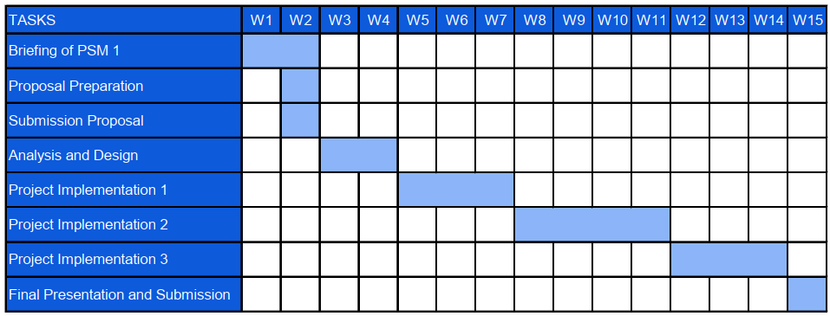
Stage-by-Stage Activities Mapping (PSM1)
- Briefing & Proposal (W1 – W2): Meeting with your supervisor, finalizing the scope of the timetable system, and submitting the formal PSM 1 proposal.

- Analysis and Design (W3 – W4): Designing the system architecture, the database schema (for subjects/groups), and the wireframes for the interactive timetable UI.

- Project Implementation 1 (W5 – W7): Core Backend & Extraction. Developing the Flask backend and writing the pdfplumber logic to successfully extract raw timetable data from the official FTMK PDFs into your database.

- Project Implementation 2 (W8 – W11): Algorithm & UI Integration. Developing the core rule-based scheduling algorithm to detect and prevent time clashes. Building the frontend interactive visual grid to display the generated schedules.

- Project Implementation 3 (W12 – W14): Advanced Features & Testing. Adding preference customizations (e.g., avoiding morning classes), the high-resolution PNG export, conducting rigorous system testing/debugging, and drafting the final report.

- Final Presentation and Submission (W15): Final polish of the documentation and presenting the working prototype to the faculty panels.

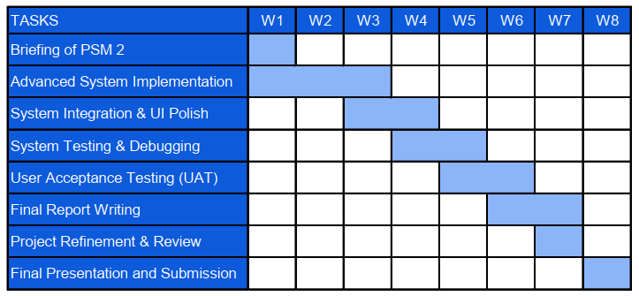

Stage-by-Stage Activities Mapping (PSM 2)
- Briefing of PSM 2 (W1): Initial Planning. Attending the initial semester briefing and finalizing the PSM 2 development and testing strategy with your supervisor.
- Advanced System Implementation (W1 – W3): Feature Expansion. Developing the remaining complex features for the system, including preference customization filters, integrating blacklist rules, and setting up the automated one-click lecturer email request function.
- System Integration & UI Polish (W3 – W4): Frontend & Backend Linking. Seamlessly connecting the backend Python/Flask rule-based algorithm with the interactive frontend visual grid, ensuring color-coding and automatic break injections render perfectly.
- System Testing & Debugging (W4 – W5): Technical Validation. Conducting rigorous technical tests to guarantee mathematical accuracy and ensuring the rule-based scheduling algorithm accurately performs time conflict checking with zero overlapping classes.
- User Acceptance Testing (UAT) (W5 – W6): User Feedback. Having a select group of FTMK students test the web application to evaluate its user-friendliness and confirming secondary features like the high-resolution PNG image export function correctly.
- Final Report Writing (W6 – W7): Thesis Documentation. Drafting the core chapters of the final PSM 2 thesis, documenting the Agile development methodology, testing phases, and project outcomes.
- Project Refinement & Review (W7): Final Polish. Implementing final UI tweaks based on UAT feedback, ensuring system responsiveness, and submitting the draft report to your supervisor for review and corrections.
- Final Presentation and Submission (W8): Project Delivery. Delivering the finalized web application and hardbound thesis, followed by the demonstration of the working system to the UTeM faculty panels.

Conclusion
This chapter presented the literature review and project methodology for the FTMK Smart Timetable Arrangement System for Students. The literature review discussed the domain of academic timetable scheduling, reviewed existing systems and their limitations, and evaluated several scheduling techniques including genetic algorithms, integer linear programming, simulated annealing, and rule-based scheduling. The rule-based scheduling approach was selected as the most suitable technique for this project due to its ability to enumerate all valid conflict-free combinations and its compatibility with preference-based filtering. The Agile development methodology was adopted to guide the iterative development of the system. The project requirements and schedule were also defined to provide a clear roadmap for the design and development phases. The next chapter presents the analysis phase, including problem analysis, requirement analysis, and a detailed discussion of the functional and non-functional requirements of the proposed system.

ANALYSIS

Introduction
This chapter presents the analysis phase of the FTMK Smart Timetable Arrangement System for Students project. The purpose of this phase is to investigate the current timetable arrangement process at FTMK, UTeM, identify the root causes of the problems faced by students, and determine the requirements needed for the proposed system. The analysis phase serves as a bridge between the problem identification conducted in Chapter 1 and the system design that will be carried out in Chapter 4.
The analysis begins with a problem analysis that examines the current system scenario through an activity diagram illustrating the existing manual timetable arrangement process. This is followed by a detailed requirement analysis covering data requirements, functional requirements, non-functional requirements, and other technical requirements. The findings from this chapter will guide the design and development of a systematic, web-based timetable arrangement system that addresses the identified limitations of the current process.

Problem Analysis
Currently, FTMK students at UTeM are required to arrange their own class schedules at the beginning of each semester. The faculty publishes an official timetable in PDF format, which contains subject codes, group options, days, times, and venues for all available classes. Students must download this PDF, manually identify the subjects they wish to register for, and compare the time slots of different group options across all their selected subjects to find a combination that does not produce any time conflicts.
This process is entirely manual and unassisted. Students must repeat the comparison process multiple times whenever they change their subject selection or discover a conflict in their chosen combination. Students who are registering for elective subjects or who are direct entry students with flexible subject selections face additional complexity due to the larger number of possible group combinations they must evaluate.
The current process does not provide any automated conflict detection, preference filtering, or structured comparison tools. As a result, students frequently encounter problems such as overlooked time conflicts, unbalanced timetable distributions with excessive gaps or back-to-back classes, and last-minute schedule changes after registration opens.
Activity Diagram — Current Manual Timetable Arrangement Process
The activity diagram below illustrates the flow of the current manual timetable arrangement process carried out by students at FTMK, UTeM.
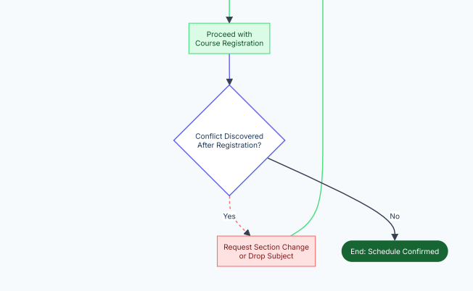
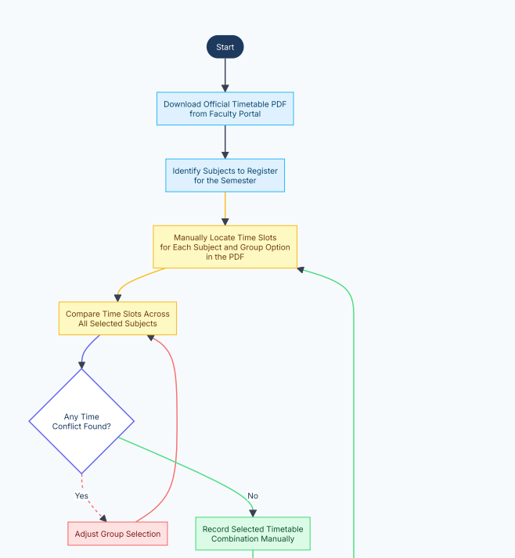

Detailed Problem Statement
Based on the current system scenario, the following problems have been identified and are explained in detail:
Problem 1 — Lack of a systematic timetable arrangement tool. The current process requires students to manually analyze a static PDF document to identify suitable timetable combinations. There is no interactive system that can process the timetable data and assist students in generating valid schedule options. This makes the process inefficient and time-consuming, particularly for students managing five or more subjects with multiple group options each.
Problem 2 — Difficulty in avoiding time conflicts. Students must manually compare the time slots of every group option across all their selected subjects. Given that a student may have five to seven subjects, each with two to four group options, the total number of possible combinations can be very large. Manual comparison significantly increases the risk of overlooking overlapping time slots and selecting a conflicting schedule.
Problem 3 — Complexity of the timetable structure. The official FTMK timetable PDF contains information for all courses and programmes simultaneously, making it dense and difficult to navigate. Students must filter out irrelevant entries and focus only on their registered subjects, which adds cognitive load and increases the likelihood of errors during the manual arrangement process.
Problem 4 — Inefficient schedule distribution. Without a tool to evaluate the quality of a timetable arrangement, students may end up with unbalanced schedules such as having too many classes on a single day, long idle gaps between classes, or early morning and late evening classes that could otherwise be avoided. There is no mechanism in the current process to optimize or compare the quality of different valid combinations.
Problem 5 — Lack of decision support. Students do not have access to any tool that can assist them in selecting the most suitable timetable from the available valid options. The absence of preference customization features, such as the ability to request a free day or avoid morning classes, means that students cannot efficiently narrow down their options based on personal preferences.
Problem 6 — High risk of human error. The entirely manual nature of the current process makes it highly susceptible to human error. Students may misread time slots, overlook group options, or incorrectly record their selected schedule, leading to conflicts that are only discovered after course registration has been submitted.

Requirement Analysis

Data Requirement

Input Data
Data | Description | Source
Timetable PDF file | Official FTMK timetable document uploaded by the administrator | Admin upload
Subject codes | Subject codes selected by the student for timetable generation | Student input
Group preferences | Preferred or blacklisted sections and time slots specified by the student | Student input
User credentials | Username and password for login and authentication | Student / Admin input

Output Data
Data | Description
Generated timetable options | All valid conflict-free timetable combinations based on selected subjects and preferences
Timetable visual grid | Color-coded weekly schedule grid rendered from a selected timetable option
Exported PNG image | High-resolution image of the selected timetable grid for download
Reports | Number of generated options and subject distribution summary

Internally Stored Data
Data Entity | Attributes
User | User ID, name, matric number, email, password hash, role (student/admin)
Subject | Subject ID, subject code, subject name, credit hours
Timetable Entry | Entry ID, subject ID, group, day, start time, end time, venue, lecturer name
Saved Timetable | Save ID, user ID, timetable combination data, date saved
Semester | Semester ID, academic year, semester number

Data Dictionary

Users
Contains authentication credentials and academic profile information for every registered user in the system.
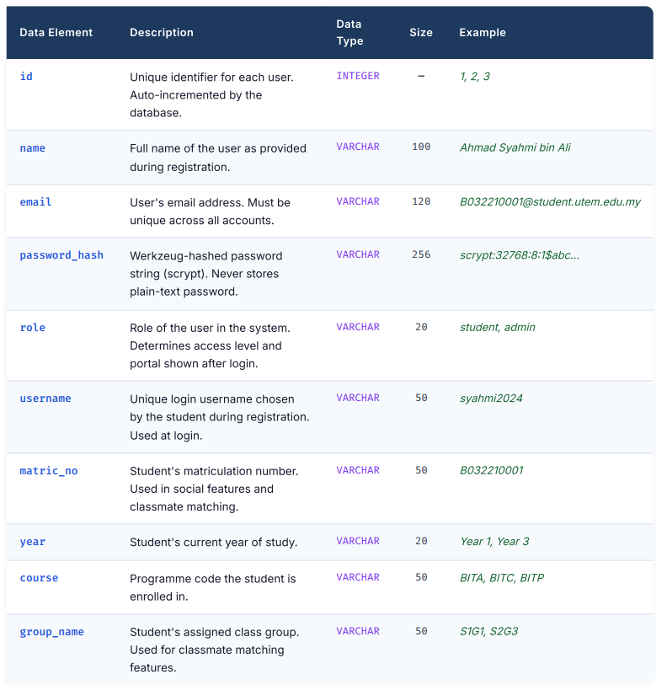

Timetable
Master timetable data extracted from faculty PDF uploads
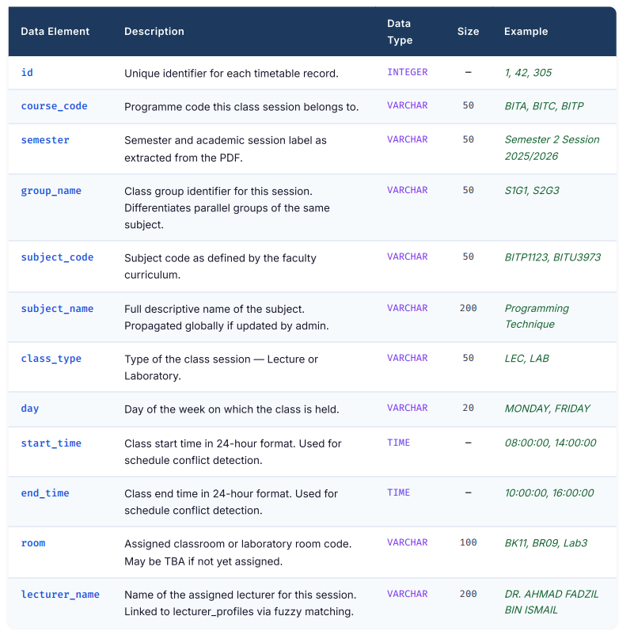

saved_timetables
Each row is one timetable combination a student has saved. The full schedule is stored as a JSON string. One record per student may be flagged as Primary.
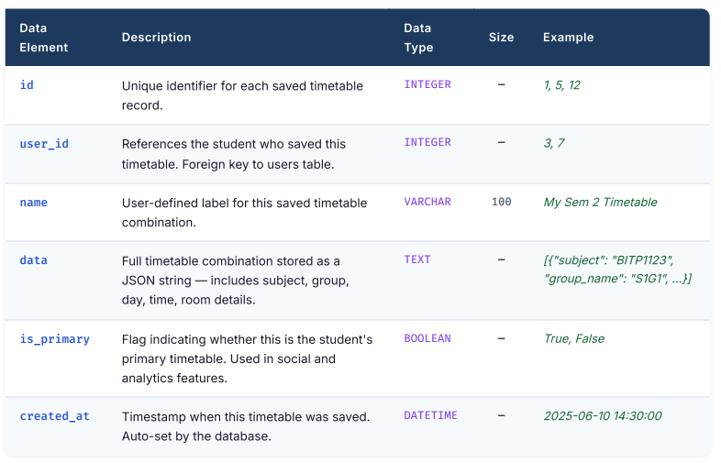

saved_friends
Records a friend link from one student to another, identified by matric number. Used to overlay timetables and find common free time slots.
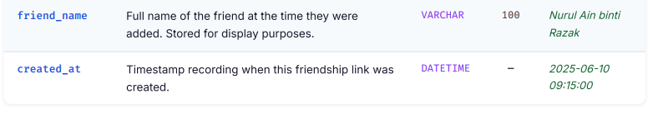
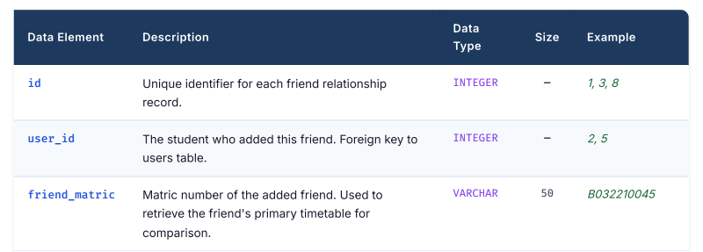

lecturer_profiles
Stores official lecturer profile data scraped from the FTMK staff directory website. Linked to timetable records at runtime via fuzzy name matching (confidence threshold > 80%).
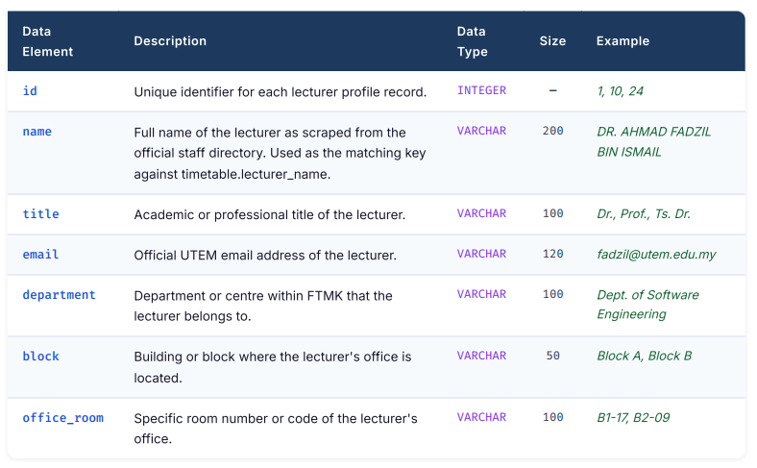

Functional Requirements
The functional requirements define what the system must do. They are organized by module and illustrated through a Use Case description.
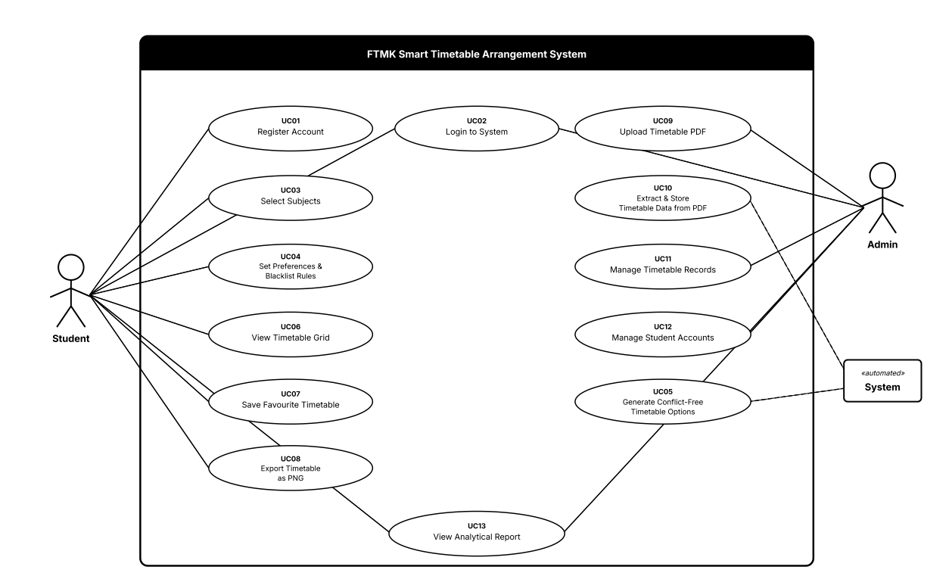

Functional Requirements by Module

Login and Registration Module
- FR01: The system shall allow new users to register an account using their name, matric number, email, and password.
- FR02: The system shall authenticate users using their registered email and password.
- FR03: The system shall differentiate between student and administrator access roles.

Timetable Data Extraction Module
- FR04: The system shall allow administrators to upload an official FTMK timetable PDF file.
- FR05: The system shall automatically extract subject codes, group names, days, start times, end times, venues, and lecturer names from the uploaded PDF using pdfplumber.
- FR06: The system shall store all extracted timetable data in the relational database.
User Input Module
- FR07: The system shall allow students to select the subjects they wish to include in their timetable generation.
- FR08: The system shall allow students to specify preferences such as preferred free days and time restrictions.
- FR09: The system shall allow students to apply blacklist rules to exclude fully booked or unwanted sections and time slots.
Timetable Arrangement Module
- FR10: The system shall generate all mathematically possible timetable combinations based on the student's selected subjects and available group options.
- FR11: The system shall apply conflict detection to filter out any combination where two or more classes overlap in time.
- FR12: The system shall apply preference and blacklist filters to further narrow down the valid timetable options.
Timetable Display Module
- FR13: The system shall display the generated timetable options in a color-coded interactive weekly grid.
- FR14: The system shall automatically inject standard break periods such as lunch breaks and Friday Prayer times into the displayed grid.
- FR15: The system shall allow students to save their preferred timetable options to a favorites list.
- FR16: The system shall allow students to export the selected timetable grid as a high-resolution PNG image.
Admin Management Module
- FR17: The system shall allow administrators to view, edit, filter, and bulk-delete timetable records in the database.
- FR18: The system shall allow administrators to register, modify, and deactivate student accounts.
Analytical and Reporting Module
- FR19: The system shall display the total number of generated conflict-free timetable options for the student's subject selection.
- FR20: The system shall provide a subject distribution summary showing how subjects are spread across days of the week for a selected timetable option.

Non-Functional Requirements
Category | Requirement
Performance | The timetable generation process shall complete within five seconds for a selection of up to seven subjects with up to four group options each under normal network conditions.
Usability | The system interface shall be intuitive and require no prior technical training for students to perform subject selection and timetable generation. All primary tasks shall be completable within three user interactions.
Reliability | The system shall maintain stable operation with a target uptime of at least 99% during active semester periods. Errors during PDF extraction shall be handled gracefully with informative feedback to the administrator.
Accuracy | The conflict detection algorithm shall produce zero false positives — no conflicting timetable combination shall be presented as valid to the student.
Security | User passwords shall be stored as hashed values using a secure hashing algorithm. Access to admin functionalities shall be restricted to accounts with the administrator role.
Scalability | The database shall be capable of storing timetable data for at least five semesters simultaneously without degradation in query response time.
Maintainability | The system codebase shall be organized into clearly separated modules to allow individual components to be updated or replaced without affecting the overall system.
Compatibility | The web application shall be accessible and fully functional on modern web browsers including Google Chrome, Mozilla Firefox, and Microsoft Edge without requiring additional plugins.

Other requirements

Hardware Requirements
Hardware | Specification | Justification
Development machine | Intel Core i5 or equivalent, minimum 8 GB RAM, 256 GB SSD | Required to run the development environment, local web server, and database simultaneously without performance issues.
Web server (deployment) | Minimum 2-core CPU, 4 GB RAM | Required to host the Flask web application and serve requests from multiple concurrent users during peak registration periods.
Network connection | Stable broadband internet | Required for accessing the web application, uploading timetable PDFs, and performing system testing across different devices.

Software Requirements
Software | Justification
Python 3.10 | Primary backend programming language selected for its extensive library support, readability, and suitability for data processing tasks such as PDF extraction and algorithmic scheduling.
Flask Framework | A lightweight Python web framework chosen for its simplicity and flexibility in building web applications with minimal overhead. Suitable for a project of this scale and complexity.
pdfplumber | A Python library specifically designed for extracting text and structured table data from PDF files. Selected over alternatives such as PyPDF2 due to its superior handling of table layouts commonly found in FTMK timetable documents.
SQLite / Postgresql | A relational database management system selected for its structured data storage capabilities. SQLite is used during development for simplicity, with Postgresql considered for deployment.
HTML, CSS, JavaScript | Standard frontend web technologies used to build the interactive timetable grid, user interface, and client-side filtering features.
Visual Studio Code | IDE selected for its rich Python and web development extension support, integrated terminal, and Git integration.

Conclusion
This chapter presented the analysis phase of the FTMK Smart Timetable Arrangement System project. The problem analysis described the current manual timetable arrangement process at FTMK, UTeM, illustrated through an activity diagram, and provided a detailed explanation of the six identified problems including lack of systematic tools, difficulty in conflict avoidance, timetable complexity, inefficient schedule distribution, lack of decision support, and high risk of human error. The requirement analysis defined the data requirements through a data dictionary, the functional requirements through a use case table organized by module, the non-functional requirements covering performance, usability, reliability, accuracy, security, scalability, maintainability, and compatibility, and the software and hardware requirements with justifications for each selection. The findings from this analysis phase provide a comprehensive foundation for the system design that will be carried out in the next chapter, which covers the system architecture, database design, user interface design, and detailed module design of the proposed system.

DESIGN

Introduction
This chapter presents the design of the FTMK Smart Timetable Arrangement System based on the requirements gathered and analysed in the preceding chapters. The chapter is divided into two main sections: High-Level Design and Detailed Design. The High-Level Design defines the overall architecture of the system, the user interface structure, and the conceptual and logical database design. The Detailed Design elaborates on the internal logic of the key software modules and the physical database structure. Together, these sections provide a complete blueprint that guides the development and implementation of the system in PSM II.

High-Level Design

System Architecture
The FTMK Smart Timetable Arrangement System follows a Three-Tier Web Architecture, which separates the system into three distinct logical layers: the Presentation Layer, the Application Logic Layer, and the Data Layer. This architecture promotes modularity, maintainability, and scalability.
Layer | Component | Technology
Presentation Layer | Web Browser UI (HTML, CSS, JavaScript) | Jinja2 Templates, Vanilla JS
Application Logic Layer | Backend Server, Routes, Business Logic | Python, Flask Framework
Data Layer | Relational Database | SQLite (development), PostgreSQL (production)

Layer 1 — Presentation Layer
The Presentation Layer consists of HTML templates rendered by the Flask Jinja2 templating engine. Students and administrators access the system through a web browser. The layer provides two distinct portals: the Student Portal and the Admin Portal. JavaScript handles dynamic client-side interactions such as timetable generation requests, real-time form validation, and AJAX-based API calls to the backend.

Layer 2 — Application Logic Layer
The Application Logic Layer is the core of the system. It is built using the Flask web framework in Python. This layer is responsible for:
- Handling HTTP requests and routing them to the appropriate handler functions
- Enforcing authentication and role-based access control using session management
- Running the Timetable Generation Algorithm (Genetic Algorithm) to produce conflict-free schedule combinations
- Executing the PDF Extraction module (using pdfplumber) when an admin uploads a timetable file
- Performing web scraping of the FTMK staff directory (using selenium and beautifulsoup4) to synchronise lecturer profiles
- Communicating with the Data Layer through SQLAlchemy ORM
Layer 3 — Data Layer
The Data Layer consists of a relational database that persistently stores all system data, including user accounts, master timetable records, saved student timetables, social friend links, and lecturer profiles. During development, SQLite is used as a lightweight embedded database. In the production environment, PostgreSQL is used for robustness and concurrent access.

Static View
The static structure of the system is represented by five database models (User, Timetable, SavedTimetable, SavedFriend, LecturerProfile) and the Flask Blueprint routing module. The app.py initialises the Flask application, binds the SQLAlchemy ORM, and registers the main Blueprint.
Dynamic View
The dynamic behaviour of the system follows the Request-Response cycle:
- The user submits an action via the browser (e.g., submitting the generate timetable form).
- The browser sends an HTTP request to the Flask server.
- Flask routes the request to the appropriate view function in routes.py.
- The view function processes the request (queries the database, runs the algorithm, or saves data).
- A JSON response or rendered HTML page is returned to the browser.
- The browser updates the UI dynamically using JavaScript.
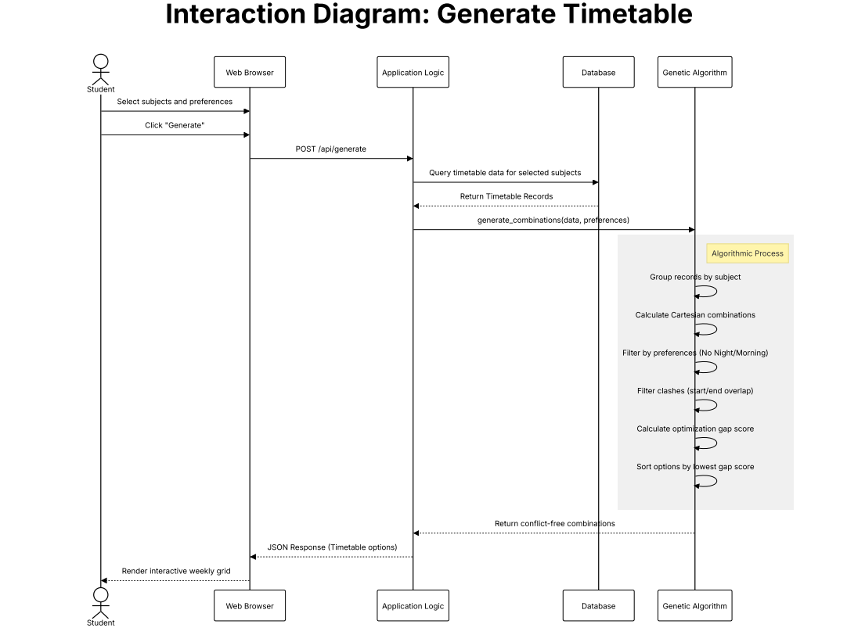

User Interface Design

Navigation Design
The system implements a role-based navigation model. Upon login, the system checks the user's role stored in the session and redirects them to the appropriate portal.
Student Navigation Flow:
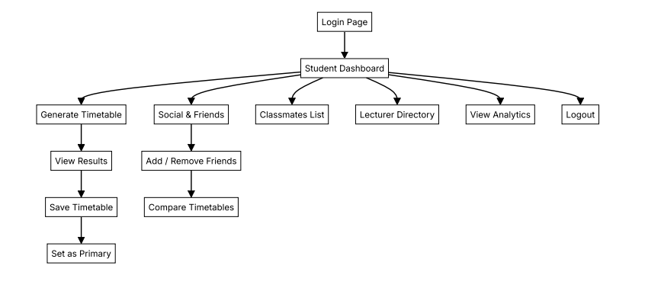
Admin Navigation Flow:
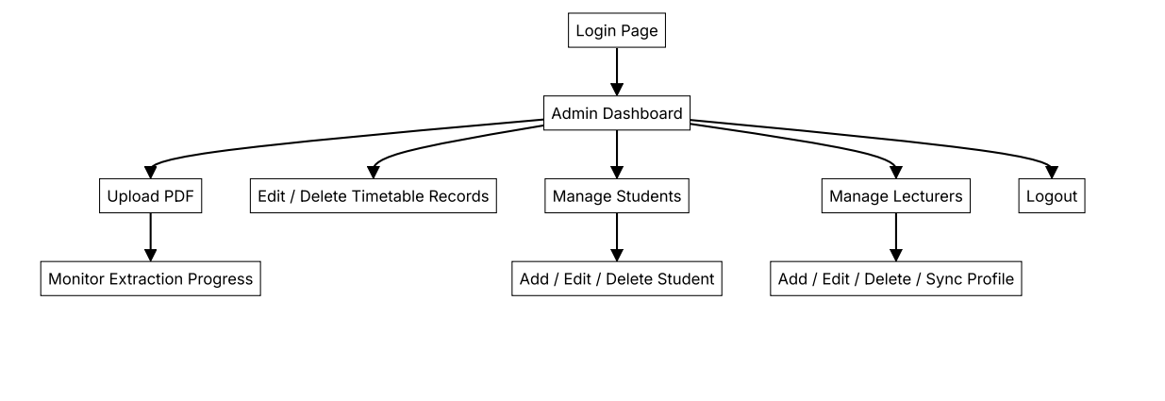

Navigation controls used in the system include:
Control Type | Usage
Sidebar navigation menu | Primary portal navigation for both Student and Admin
Tab navigation | Switching between semesters and courses in the Admin timetable view
Modal dialogs | Add/Edit/Delete forms for students and lecturers
Breadcrumb indicators | Showing current page context
Button groups | Generate, Save, Set as Primary timetable actions

Input Design
The following describes the key input screens and their field specifications:
Registration Form
Field | Input Type | Validation Rule
Full Name | Text | Required, max 100 characters
Username | Text | Required, unique, max 50 characters
Email | Email | Required, unique, valid email format
Matric Number | Text | Required, unique, max 50 characters
Password | Password | Required, min 8 chars, must contain uppercase, lowercase, digit, and special character
Course | Dropdown | Required, selected from predefined list
Year of Study | Dropdown | Required, selected from predefined list
Group | Text | Required, max 50 characters

Timetable Generation Form
Field | Input Type | Validation Rule
Subject Selection | Multi-select checkbox | At least one subject must be selected
No Night Classes | Toggle checkbox | Optional preference
No Morning Classes | Toggle checkbox | Optional preference
Free Day Preference | Dropdown | Optional, selects one day to keep free
Preferred Group | Text | Optional, applies group prioritisation score

Admin — Upload PDF Form
Field | Input Type | Validation Rule
Semester Name | Text | Required, used to label extracted records
PDF File | File upload | Required, must be a valid PDF file (.pdf)

Admin — Add / Edit Student Form
Field | Input Type | Validation Rule
Full Name | Text | Required
Username | Text | Required, unique
Email | Email | Required, unique, valid format
Matric Number | Text | Required, unique
Password | Password | Required (on add); optional (on edit)
Course | Text | Required
Year | Text | Required
Group | Text | Optional

Output Design
The system produces the following types of outputs:
Output | Type | Basis | Description
Timetable Combination Grid | Visual (weekly calendar grid) | Ad-hoc (on-demand) | Displays generated conflict-free timetable options in a weekly schedule view
Saved Timetable View | Visual grid | Ad-hoc | Renders the student's saved timetable combinations on request
Timetable PNG Export | Image file download | Ad-hoc | Allows students to export their timetable view as a PNG image
Friend Timetable Overlay | Visual comparative grid | Ad-hoc | Overlays two students' timetables to show common free time
Analytics Dashboard | Summary report with charts | Ad-hoc | Displays statistics of the student's primary timetable: total hours, busiest day, lecture vs lab ratio
Classmates Report | List / summary report | Ad-hoc | Lists students sharing the same subject-group combinations as the logged-in student
Lecturer Directory | Detail report | Ad-hoc | Lists all lecturers with their subjects, schedule, email, and office room
Master Timetable Table | Detail tabular report | Ad-hoc | Shows admin all raw timetable records grouped by semester and course code

Database Design

Conceptual and Logical Database Design
Introduction to the Logical Data Model
The logical data model for the FTMK Smart Timetable Arrangement System is represented using an Entity-Relationship (ER) diagram. The ER diagram defines the entities that exist within the system, the attributes that describe each entity, and the relationships and cardinalities between them. The logical data model serves as the foundation for the physical database schema and ensures that the data structure correctly reflects the business rules and functional requirements of the system.
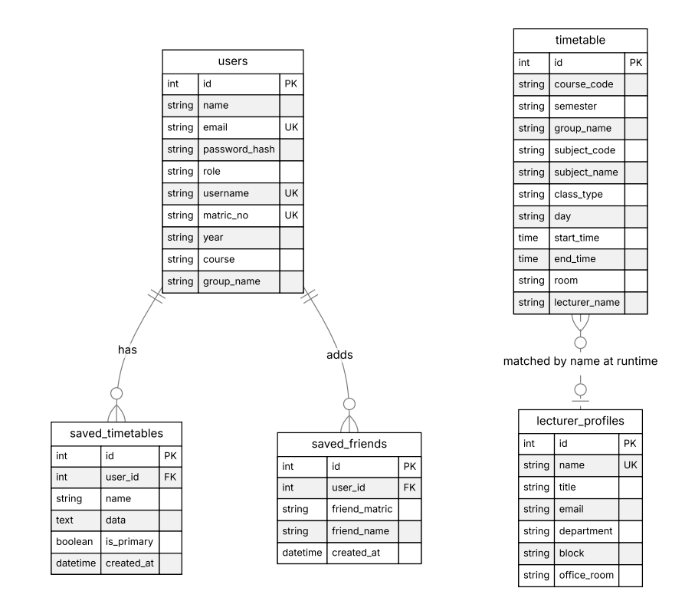

Entity Descriptions and Business Rules
Entity | Description | Business Rules
User | Stores account credentials and academic profile | Each user must have a unique email, username, and matric number. Role is either 'admin' or 'student'.
Timetable | One record per class session (subject + group + day + time) | Populated by admin via PDF upload only. Each record belongs to one semester and one course code.
SavedTimetable | A student's saved schedule combination | A student may save multiple timetables but only one can be set as primary at a time.
SavedFriend | A directional friend link from one student to another | A student cannot add themselves. Each friend is identified by matric number.
LecturerProfile | Lecturer's name, title, email, department, and office | Name must be unique. Populated by web scraping the FTMK staff directory website.

Relationships and Cardinalities
Relationship | Cardinality | Description
User — SavedTimetable | One-to-Many (1:N) | One student can have many saved timetables
User — SavedFriend | One-to-Many (1:N) | One student can have many saved friends
Timetable — LecturerProfile | Many-to-One (N:1, logical) | Many timetable records may reference the same lecturer; matched via fuzzy name matching at runtime
SavedTimetable.data — Timetable | Embedded (denormalised) | The saved timetable data is a JSON snapshot copied from the Timetable table at save time, ensuring data integrity even if master records change

Database Normalization
Unnormalized Form (UNF)
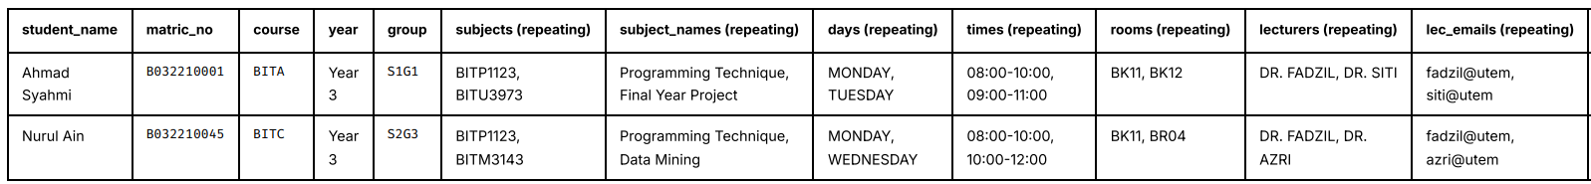
First Normal Form (1NF)
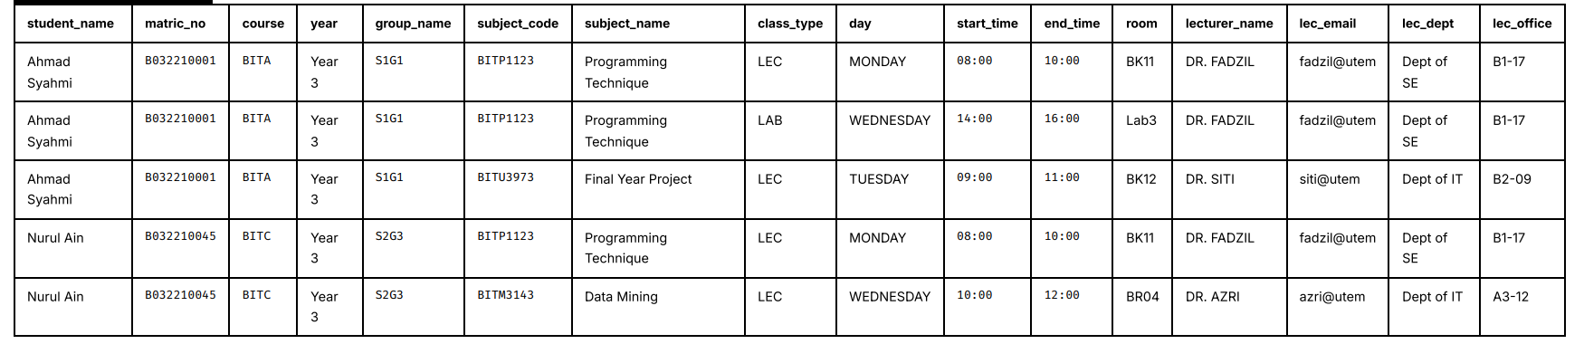
Second Normal Form (2NF)
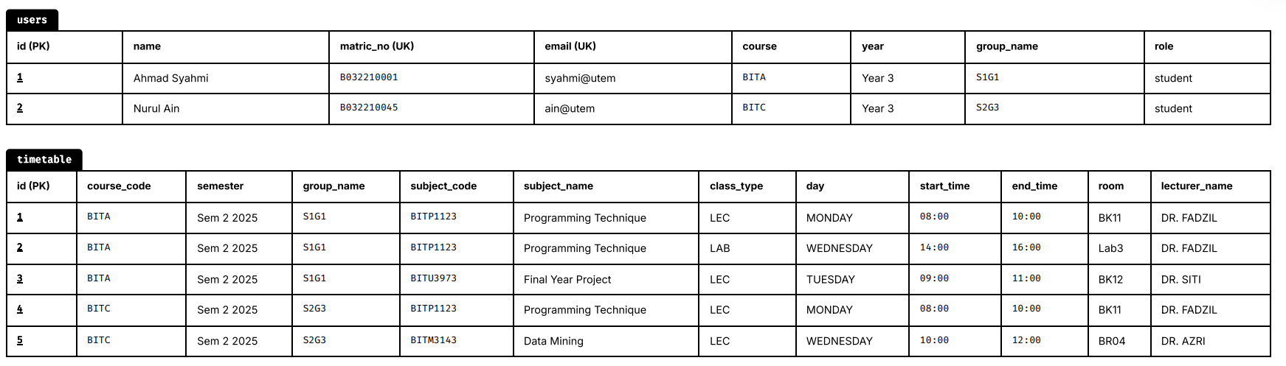
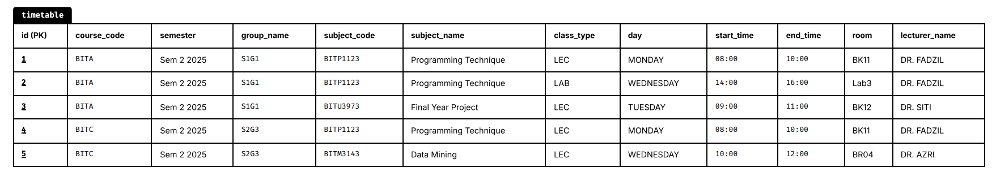
Third Normal Form (3NF)
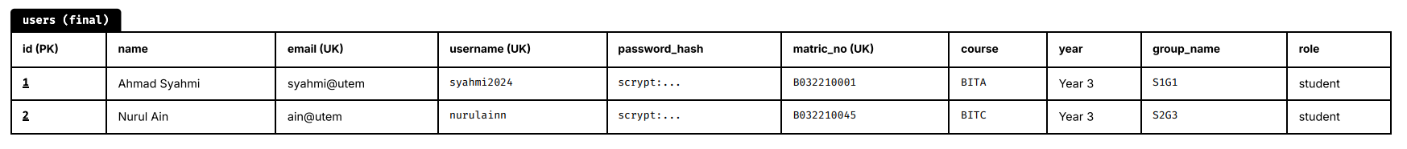
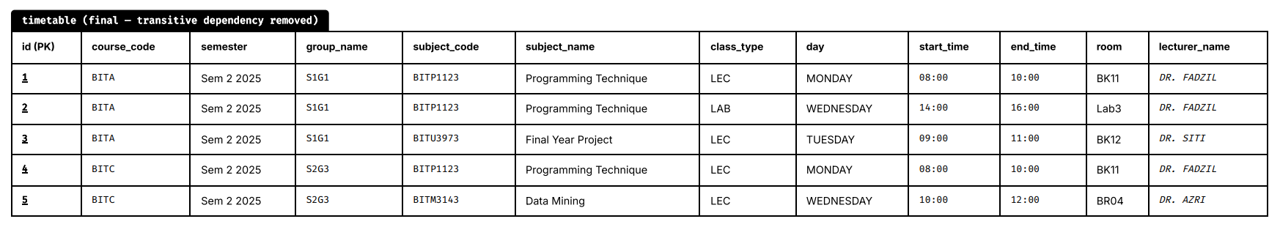
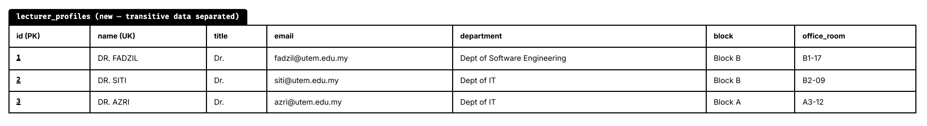
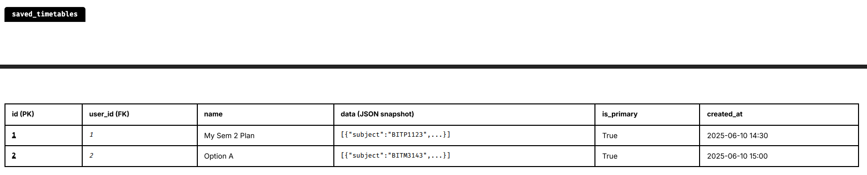
The database design follows the Third Normal Form (3NF):
- 1NF: All attributes hold atomic, single-valued data. No repeating groups exist.
- 2NF: All non-key attributes in each table are fully functionally dependent on the primary key.
- 3NF: No transitive dependencies exist between non-key attributes. For example, lecturer contact details are separated into the lecturer_profiles table rather than being duplicated in every timetable record.
The only intentional deviation from full normalisation is the data column in saved_timetables, which stores a JSON snapshot. This is a deliberate denormalisation to preserve the historical integrity of a student's saved choice.

Detailed Design

Software Design
Module 1: User Authentication
Description: Manages user login, session creation, and logout. Enforces role-based access control on all protected routes.
Input: Username (string), Password (string)
Output: Session token with user_id and role; redirect to appropriate dashboard
Pre-condition: User must be registered in the users table.
Post-condition: If credentials are valid, a session is created and the user is redirected. If invalid, an error message is displayed.
Algorithm:
1. Receive username and password from login form
2. Query users table WHERE username = input_username
3. IF user found AND check_password(input_password, password_hash) == True:
a. Set session['user_id'] = user.id
b. Set session['role'] = user.role
c. IF role == 'admin': redirect to Admin Dashboard
ELSE: redirect to Student Dashboard
4. ELSE: flash('Invalid credentials') and reload login page
Module 2: PDF Timetable Extraction
Description: Parses an uploaded faculty timetable PDF file and extracts structured class session records, which are then stored in the timetable table.
Input: PDF file (binary), Semester Name (string)
Output: N parsed Timetable records inserted into the database
Pre-condition: Admin must be logged in. A valid PDF file must be uploaded.
Post-condition: Database contains new Timetable records for the given semester.
Algorithm:
1. Receive uploaded PDF file and semester name
2. Save PDF to server uploads directory
3. Spawn background thread with task_id
4. In background thread:
a. Open PDF using pdfplumber
b. For each page, extract text tables
c. Parse rows to identify: course_code, group_name, subject_code,
subject_name, class_type, day, start_time, end_time, room, lecturer_name
d. For each parsed row:
i. Create Timetable object
ii. Add to database session
e. Commit all records
f. Update EXTRACTION_PROGRESS[task_id] = 100%, 'completed'
5. Client polls /api/progress/<task_id> until status == 'completed'

Module 3: Timetable Generation (Conflict-Free Scheduling Algorithm)
Description: Generates all valid, conflict-free timetable combinations from the student's selected subjects using a combinatorial algorithm with preference filtering and gap-score optimisation.
Input: subjects_data (dict of subject_code → list of group bundles), Preferences (no_night, no_morning, free_day, preferred_group)
Output: Sorted list of valid timetable combinations (lowest gap score first)
Pre-condition: At least one subject with available group data must be selected.
Post-condition: Returns a ranked list of non-clashing combinations, or an empty list if none exist.
Algorithm:
1. For each selected subject, collect all available group bundles
2. Compute Cartesian product of all group bundles across all subjects
(one group per subject per combination)
3. For each combination:
a. Flatten all class sessions into a single list
b. Apply preference filters:
- IF no_night AND any class starts/ends after 20:00 → discard
- IF no_morning AND any class starts before 10:00 → discard
- IF free_day AND any class falls on free_day → discard
c. Check all pairs of classes for time conflict:
Conflict = same day AND (start1 < end2 AND start2 < end1)
IF conflict found → discard combination
d. Calculate gap score:
For each day, sort classes chronologically
Gap = sum of idle minutes between consecutive classes
e. IF preferred_group specified:
Add penalty of 100,000 per subject not in preferred group
4. Sort remaining valid combinations by ascending gap score
5. Return sorted combinations and perfect_match flag

Module 4: Save and Set Primary Timetable
Description: Allows students to save a generated timetable combination to their profile and optionally mark it as their primary timetable.
Input: Timetable data (JSON), User ID (integer), Name (string)
Output: New SavedTimetable record in database
Pre-condition: Student must be logged in. Timetable data must be a valid JSON array.
Post-condition: Timetable is saved. If set as primary, all other saved timetables for the user have is_primary set to False.
Algorithm:
1. Receive timetable JSON and optional name from student
2. Create SavedTimetable record with user_id, name, data = JSON string
3. INSERT into saved_timetables table
4. IF set_as_primary:
a. UPDATE saved_timetables SET is_primary = False WHERE user_id = current_user
b. UPDATE this record SET is_primary = True
5. COMMIT transaction
6. Return success response

Module 5: Social Timetable Comparison
Description: Retrieves and overlays a friend's primary timetable against the logged-in student's primary timetable to identify common free time slots.
Input: Friend's matric number (string)
Output: JSON containing both timetables for client-side overlay rendering
Pre-condition: Both the current student and the friend must have set a primary timetable.
Post-condition: Both timetables are returned for the client to render side-by-side or as an overlay.

Algorithm:
1. Receive friend_matric from request
2. Query users WHERE matric_no = friend_matric AND role = 'student'
3. IF not found → return 404 error
4. Query saved_timetables WHERE user_id = friend.id AND is_primary = True
5. IF not found → return error: friend has no primary timetable
6. Query saved_timetables WHERE user_id = current_user AND is_primary = True
7. IF not found → return error: current user has no primary timetable
8. Return JSON: { friend_name, friend_data, my_data }

Module 6: Lecturer Profile Sync (Web Scraping)
Description: Scrapes the official FTMK staff directory website using Selenium and BeautifulSoup4, then inserts or updates lecturer profiles in the lecturer_profiles table.
Input: None (triggered by admin clicking Sync)
Output: Updated LecturerProfile records in database
Pre-condition: Admin must be logged in. Internet connection must be available.
Post-condition: New lecturer profiles are inserted; existing ones are updated with latest data.
Algorithm:
1. Launch headless Chromium browser using Selenium WebDriver
2. Navigate to FTMK staff directory URL
3. Parse HTML using BeautifulSoup4
4. For each lecturer entry, extract: name, title, email, department, block, office_room
5. For each extracted profile:
a. Query lecturer_profiles WHERE name = extracted_name
b. IF found → UPDATE existing record with new data
ELSE → INSERT new LecturerProfile record
6. COMMIT transaction
7. Return count of added and updated profiles

Physical Database Design
-- Table 1: users
CREATE TABLE users (
id SERIAL PRIMARY KEY,
name VARCHAR(100) NOT NULL,
email VARCHAR(120) UNIQUE NOT NULL,
password_hash VARCHAR(256) NOT NULL,
role VARCHAR(20) NOT NULL DEFAULT 'student',
username VARCHAR(50) UNIQUE,
matric_no VARCHAR(50) UNIQUE,
year VARCHAR(20),
course VARCHAR(50),
group_name VARCHAR(50)
);

-- Table 2: timetable
CREATE TABLE timetable (
id SERIAL PRIMARY KEY,
course_code VARCHAR(50),
semester VARCHAR(50),
group_name VARCHAR(50),
subject_code VARCHAR(50),
subject_name VARCHAR(200),
class_type VARCHAR(50),
day VARCHAR(20),
start_time TIME,
end_time TIME,
room VARCHAR(100),
lecturer_name VARCHAR(200)
);

-- Index: speed up filtering by semester and course
CREATE INDEX idx_timetable_semester ON timetable(semester);
CREATE INDEX idx_timetable_course ON timetable(course_code);
CREATE INDEX idx_timetable_subject ON timetable(subject_code);

-- Table 3: saved_timetables
CREATE TABLE saved_timetables (
id SERIAL PRIMARY KEY,
user_id INTEGER NOT NULL REFERENCES users(id) ON DELETE CASCADE,
name VARCHAR(100) NOT NULL DEFAULT 'My Saved Timetable',
data TEXT NOT NULL,
is_primary BOOLEAN DEFAULT FALSE,
created_at TIMESTAMP DEFAULT CURRENT_TIMESTAMP
);
-- Index: speed up student timetable lookups
CREATE INDEX idx_saved_tt_user ON saved_timetables(user_id);
-- Table 4: saved_friends
CREATE TABLE saved_friends (
id SERIAL PRIMARY KEY,
user_id INTEGER NOT NULL REFERENCES users(id) ON DELETE CASCADE,
friend_matric VARCHAR(50) NOT NULL,
friend_name VARCHAR(100) NOT NULL,
created_at TIMESTAMP DEFAULT CURRENT_TIMESTAMP
);
-- Index: speed up friend lookups per student
CREATE INDEX idx_friends_user ON saved_friends(user_id);
-- Table 5: lecturer_profiles
CREATE TABLE lecturer_profiles (
id SERIAL PRIMARY KEY,
name VARCHAR(200) UNIQUE NOT NULL,
title VARCHAR(100),
email VARCHAR(120),
department VARCHAR(100),
block VARCHAR(50),
office_room VARCHAR(100)
);
-- Index: speed up fuzzy name matching
CREATE INDEX idx_lecturer_name ON lecturer_profiles(name);

Constraint Summary
Table | Constraint | Type | Rule
users | email | UNIQUE | No two users may share the same email
users | username | UNIQUE | No two users may share the same username
users | matric_no | UNIQUE | No two users may share the same matric number
users | role | CHECK (implicit) | Value must be 'admin' or 'student'
saved_timetables | user_id | FOREIGN KEY | Must reference a valid users.id; cascades on delete
saved_friends | user_id | FOREIGN KEY | Must reference a valid users.id; cascades on delete
lecturer_profiles | name | UNIQUE | No duplicate lecturer profiles

Conclusion
This chapter has presented the complete system design for the FTMK Smart Timetable Arrangement System, covering both high-level and detailed perspectives. The system is built on a Three-Tier Web Architecture, separating presentation, business logic, and data concerns into distinct layers. The Flask framework serves as the application backbone, supported by SQLAlchemy for database interaction and a combinatorial scheduling algorithm for conflict-free timetable generation.
The user interface design defines clear navigation flows for both Student and Admin roles, with well-structured input forms and validation rules to ensure data integrity. The output design caters to a range of ad-hoc information needs, from visual timetable grids and PNG exports to analytics dashboards and lecturer directories.
The database design is normalised to Third Normal Form (3NF), with five core tables and appropriate foreign key constraints and indexes to ensure referential integrity and query performance. The physical DDL has been defined targeting the PostgreSQL DBMS for production deployment.
In the next phase (PSM II), the designs presented in this chapter will be translated into a fully functional implemented system, with further refinement to the user interface, performance optimisation, and system testing.

IMPLEMENTATION

About List of Tables
To update List of Tables, place the cursor on the list that needs to be updated. Similar to the Table of Content, click on the icon “Update Table” under References tab to list down the updates, as shown in Figure 4.1

About List of Figures
To update List of Figures, place the cursor on the list that needs to be updated. Next, click on the icon “Update Table” under References tab to list down the updates, as shown in Figure 4.1.

About List of Figures
To update List of Figures, place the cursor on the list that needs to be updated. Next, click on the icon “Update Table” under References tab to list down the updates, as shown in Figure 4.1.

About List of Figures
To update List of Figures, place the cursor on the list that needs to be updated. Next, click on the icon “Update Table” under References tab to list down the updates, as shown in Figure 4.1.

About List of Figures
To update List of Figures, place the cursor on the list that needs to be updated. Next, click on the icon “Update Table” under References tab to list down the updates, as shown in Figure 4.1.

TESTING

About References
All works or studies referred to in the research report in the form of quotations or citations must be included in the references. The references should be written consistently in the Harvard Referencing format or in another format approved by the faculty. Students are encouraged to use reference manager software such as Mendeley to assist in creating citations and references.
Choose “Body Text 3” style for the list of the references.

PROJECT CONCLUSION

Wrap-Up
Please enjoy writing your FYP

references

Buchwalow, I. B., and Böcker, W. (2010). Immunohistochemistry: basics and methods. Berlin: Springer Verlag.

Caamaño-Tubío, R. I., Pérez, J., Ferreiro, S., and Aldegunde, M. (2007). Peripheral serotonin dynamics in the rainbow trout (Oncorhynchus mykiss) Comparative Biochemistry and Physiology Part C: Toxicology & Pharmacology. 145(2): 245-255.

Cameron, A. A., Plenderleith, M. B. and Snow, P. J. (1990). Organization of the spinal cord in four species of elasmobranch fishes: cytoarchitecture and distribution of serotonin and selected neuropeptides. The Journal of Comparative Neurology. 297: 201-218.

Desa, M.I (1995). Bus fleet maintenance modeling in a developing country. Ph.D Thesis, University of Salford.

Improve indigenous housing now, government told, 2007. accessed 8 February 2009, <http://www.architecture.com.au/i-cms?page=10220>.

International Narcotics Control Board 1999, United Nations, accessed 1 October 1999, <http://www.incb.org>.

Theusen, G. J. and Fabrycky, W. J. (1984). Engineering Economy. 6th. Ed. Englewood Cliffs, N. J.: Prentice Hall. 150-178.

For footnote, choose Footnote style

